For 24 years, we have fought for the lives of Families in Recovery. We have a spirit of gratitude for the hand of fellowship and support you have extended to us over all these years…through all the challenges you have stuck by our side. You honor our vision and you honor God with your faithfulness. Thank you.

As we enter December and you begin to consider your year-end charitable giving, we'd invite you to remember Glorybound Ministries. Glorybound is such a unique ministry. We provide the opportunity for families in recovery to receive the much needed care & concern that are so often forgotten within the addiction/treatment cycle. Many Christians have never considered nor can imagine what it is like to be caught up in this challenging lifestyle. We're bringing the Glorybound model and message into as many different churches as possible, allowing the body of Christ to be the hands & feet of Jesus to these precious families, whose numbers & needs grow each year. But, in order to continue this ministry, we need your on-going support.
Here’s what your resources can mean to families served by Glorybound:
- $45 means Christmas dinner for a family of four.
- $80 affords warm coats for two children.
- $75 helps provide a bus cards and gas for transporting family members.
- $100 buys hygiene and cleaning supplies for a family in need.
- $150 provides a family of four with food for one week.
- $450 can mean all of the above.
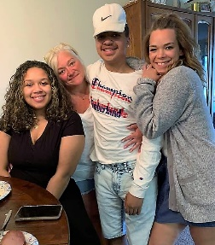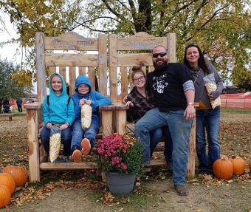
If you believe in what we're doing, would you help us get through this year and begin the new year with a solid financial support base? Here are some of simple ways to contribute:
1. Sign up to become a regular monthly donor through direct donation. Large, one-time gifts are always great. But the backbone and stability of our finances comes from individuals who make a consistent monthly donation. It makes a big difference that encourages us as we seek to carry on this mission. Just go to our website and click on the Donation link to get started.
2. Donate quickly and easily with your credit card online. Again, just go to our website, www.gloryboundmn.org and click on the donate now link.
3. You can simply mail in a check to: Glorybound Ministries, PO Box 2535 Maple Grove, MN 55311
Through your help and partnership, we will continue to provide for families in recovery. Though not the addict, they are equally as affected by the addiction but, their needs are left out when it comes to the treatment. We will continue to provide that model of love and support to these families as they fight to restore their families. Glorybound will continue to reach out with a message and demonstration of God’s love for us through Jesus Christ our Lord & Savior.
May you and your family be blessed this holiday season and in the New Year.
Sharon Thomas, Servant

